Valeriy Lazarenko, Data Science Camp Test Tasks
Task 1:
X = (0, -1, 1)
Source code
Task 2:
0 0 0 0 0 0 0
0 0 0 0 0 0 0
0 0 0 0 0 0 0
0 0 0 0 0 0 0
0 0 0 0 0 0 0
0 0 0 0 0 0 0
1 0 0 0 0 0 1
Source code
Task 2.1:
Source code
Task 2.2:
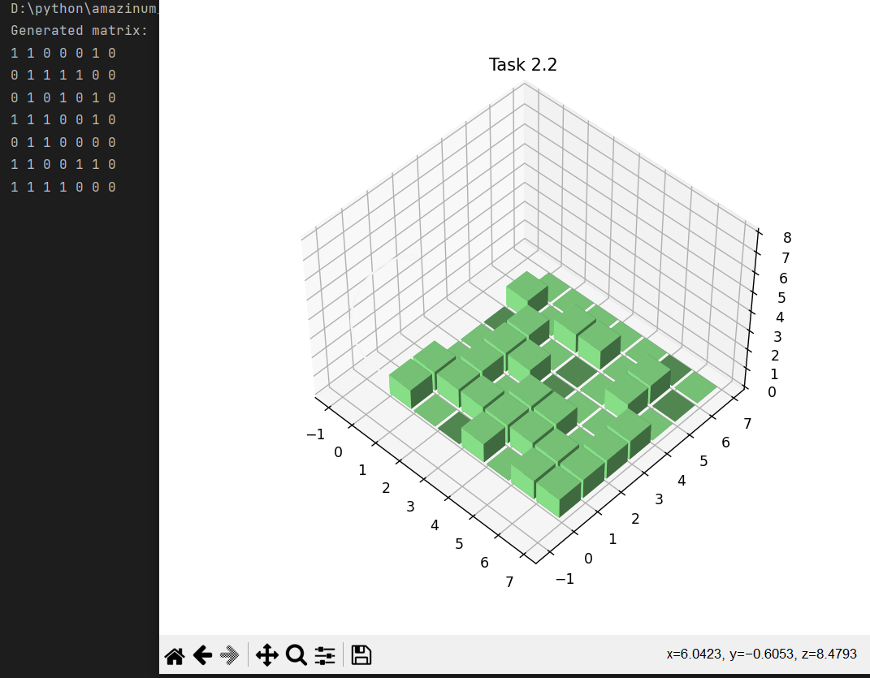
Source code

Task 3:
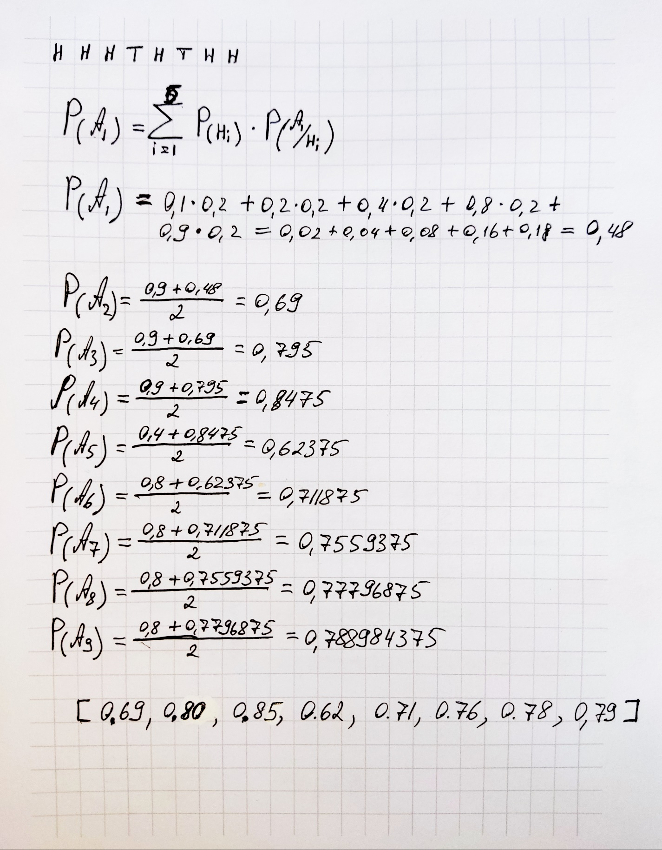
Code of task 1:
def input_matrix():
A = [[], [], []]
for i in range(3):
print("Enter %d line of matrix A and divide nums by space: " % (i+1))
A[i] = list(map(int, input().split(" ")))
B = input("Enter matrix B and divide nums by space: ").split(" ")
B = list(map(int, B))
caltulate(A, B)
def caltulate(A, B):
determinant = A[0][0] * A[1][1] * A[2][2] + A[0][1] * A[1][2] * A[2][0] + A[0][2] * A[1][0] * A[2][1] - \
A[0][2] * A[1][1] * A[2][0] - A[0][1] * A[1][0] * A[2][2] - A[0][0] * A[1][2] * A[2][1]
determinant1 = B[0] * A[1][1] * A[2][2] + B[1] * A[0][2] * A[2][1] + B[2] * A[0][1] * A[1][2] - \
B[2] * A[1][1] * A[0][2] - B[1] * A[0][1] * A[2][2] - B[0] * A[1][2] * A[2][1]
determinant2 = (A[0][0] * B[1] * A[2][2]) + (A[1][0] * B[2] * A[0][2]) + (A[2][0] * B[0] * A[1][2]) - \
(A[0][2] * B[1] * A[2][0]) - (A[1][0] * B[0] * A[2][2]) - (A[0][0] * B[2] * A[1][2])
determinant3 = A[0][0] * A[1][1] * B[2] + A[1][0] * A[2][1] * B[0] + A[2][0] * A[0][1] * B[1] - \
A[2][0] * A[1][1] * B[0] - A[0][1] * A[1][0] * B[2] - A[2][1] * A[0][0] * B[1]
if determinant != 0:
x = determinant1 / determinant
y = determinant2 / determinant
z = determinant3 / determinant
print("X = (%d, %d, %d)" % (x, y, z))
elif determinant == 0 and (determinant1 != 0 or
determinant2 != 0 or
determinant3!= 0):
print("Matrix don't have solution.")
elif determinant == 0 and determinant1 == 0 \
and determinant2 == 0 and determinant3 == 0:
print("Matrix have an infinite number of solutions.")
if __name__ == '__main__':
input_matrix()
Go back

Code of task 2:
def life(matrix, rows, cells, lifeCycle):
# Array for counting of cell's neighbours
neighbours = [[0, 0, 0, 0, 0, 0, 0],
[0, 0, 0, 0, 0, 0, 0],
[0, 0, 0, 0, 0, 0, 0],
[0, 0, 0, 0, 0, 0, 0],
[0, 0, 0, 0, 0, 0, 0],
[0, 0, 0, 0, 0, 0, 0],
[0, 0, 0, 0, 0, 0, 0]]
for iteration in range(lifeCycle):
# This cycle counts neighbours
for row in range(rows):
for cell in range(cells):
if matrix[row][cell] == 1:
if cell < 6:
neighbours[row][cell + 1] += 1
if cell > 0:
neighbours[row][cell - 1] += 1
for ncell in range(-1, 2):
position = cell + ncell
if row < 6 and 6 >= position >= 0:
neighbours[row + 1][position] += 1
if row > 0 and 6 >= position >= 0:
neighbours[row - 1][position] += 1
# This cycle check neighbours' amount and change cell's status
for row in range(rows):
for cell in range(cells):
if matrix[row][cell] == 1:
if neighbours[row][cell] <= 1 or neighbours[row][cell] >= 4:
matrix[row][cell] = 0
if matrix[row][cell] == 0 and neighbours[row][cell] == 3:
matrix[row][cell] = 1
# This cycle print matrix in console
for row in range(rows):
for cell in range(cells):
print(matrix[row][cell], end=' ')
print("")
if __name__ == '__main__':
matrix = [[1, 0, 0, 0, 0, 0, 0],
[0, 0, 1, 0, 0, 1, 1],
[1, 0, 0, 1, 0, 0, 1],
[0, 1, 1, 0, 1, 1, 0],
[1, 1, 1, 1, 0, 0, 1],
[1, 1, 1, 1, 1, 1, 1],
[1, 1, 0, 1, 1, 0, 1]]
# life(matrix_name, rows in matrix, columns, iterations)
life(matrix, len(matrix), len(matrix[0]), 7)

Go back

Code of task 2.1:
import random
def show_matrix(matrix):
for row in range(len(matrix)):
for cell in range(len(matrix)):
print(matrix[row][cell], end=' ')
print("")
print("")
def generate_matrix():
matrix = []
for i in range(7):
a = []
for j in range(7):
a.append(random.randint(0, 1))
matrix.append(a)
print("Generated matrix: ")
show_matrix(matrix)
# life(matrix_name, size, iterations)
life(matrix, 7)
def life(matrix, size):
# Array for counting of cell's neighbours
neighbours = [[0, 0, 0, 0, 0, 0, 0],
[0, 0, 0, 0, 0, 0, 0],
[0, 0, 0, 0, 0, 0, 0],
[0, 0, 0, 0, 0, 0, 0],
[0, 0, 0, 0, 0, 0, 0],
[0, 0, 0, 0, 0, 0, 0],
[0, 0, 0, 0, 0, 0, 0]]
while True:
# This cycle counts neighbours
for row in range(size):
for cell in range(size):
if matrix[row][cell] == 1:
if cell < 6:
neighbours[row][cell + 1] += 1
if cell > 0:
neighbours[row][cell - 1] += 1
for ncell in range(-1, 2):
position = cell + ncell
if row < 6 and 6 >= position >= 0:
neighbours[row + 1][position] += 1
if row > 0 and 6 >= position >= 0:
neighbours[row - 1][position] += 1
# This cycle check neighbours' amount and change cell's status
for row in range(size):
for cell in range(size):
if matrix[row][cell] == 1:
if neighbours[row][cell] <= 1 or neighbours[row][cell] >= 4:
matrix[row][cell] = 0
if matrix[row][cell] == 0 and neighbours[row][cell] == 3:
matrix[row][cell] = 1
answer = input("Generate the next iteration? (y/n) ")
if answer == "y":
print("Changed matrix: ")
show_matrix(matrix)
for var1 in range(len(neighbours)):
for var2 in range(len(neighbours[var1])):
neighbours[var1][var2] = 0
else:
quit()
if __name__ == '__main__':
generate_matrix()
Go back

Code of task 2.2:
import random
import numpy as np
import matplotlib.pyplot as plt
def generate_matrix():
matrix = []
for i in range(7):
a = []
for j in range(7):
a.append(random.randint(0, 1))
matrix.append(a)
print("Generated matrix: ")
show_matrix(matrix)
show_matrix_chart(matrix)
# life(matrix_name, size, iterations)
life(matrix, 7, 1)
def life(matrix, size, lifeCycle):
# Array for counting of cell's neighbours
neighbours = [[0, 0, 0, 0, 0, 0, 0],
[0, 0, 0, 0, 0, 0, 0],
[0, 0, 0, 0, 0, 0, 0],
[0, 0, 0, 0, 0, 0, 0],
[0, 0, 0, 0, 0, 0, 0],
[0, 0, 0, 0, 0, 0, 0],
[0, 0, 0, 0, 0, 0, 0]]
for iteration in range(lifeCycle):
# This cycle counts neighbours
for row in range(size):
for cell in range(size):
if matrix[row][cell] == 1:
if cell < 6:
neighbours[row][cell + 1] += 1
if cell > 0:
neighbours[row][cell - 1] += 1
for ncell in range(-1, 2):
position = cell + ncell
if row < 6 and 6 >= position >= 0:
neighbours[row + 1][position] += 1
if row > 0 and 6 >= position >= 0:
neighbours[row - 1][position] += 1
# This cycle check neighbours' amount and change cell's status
for row in range(size):
for cell in range(size):
if matrix[row][cell] == 1:
if neighbours[row][cell] <= 1 or neighbours[row][cell] >= 4:
matrix[row][cell] = 0
if matrix[row][cell] == 0 and neighbours[row][cell] == 3:
matrix[row][cell] = 1
print("Changed matrix: ")
show_matrix(matrix)
show_matrix_chart(matrix)
ask_user()
def show_matrix(matrix):
for row in range(len(matrix)):
for cell in range(len(matrix)):
print(matrix[row][cell], end=' ')
print("")
print("")
def show_matrix_chart(matrix):
fig = plt.figure(figsize=(7, 7))
ax1 = fig.add_subplot(projection='3d')
_x = np.arange(7)
_y = np.arange(7)
_xx, _yy = np.meshgrid(_x, _y)
x, y = _xx.ravel(), _yy.ravel()
_tup = np.array(matrix)
top = _tup[x, y]
bottom = np.zeros_like(top)
width = depth = 0.9
z2 = np.linspace(0, 8)
x2 = np.sin(z2)
y2 = np.cos(z2)
ax1.bar3d(x, y, bottom, width, depth, top, color='#98FB98')
ax1.plot3D(x2, y2, z2, '#f5f5f5')
ax1.set_title('Task 2.2')
plt.show()
def ask_user():
answer = input("Generate the next matrix? (y/n) ")
if answer == "y":
generate_matrix()
else:
quit()
if __name__ == '__main__':
generate_matrix()
Go back

Code of task 3:
def count_full_probability(coins1, tr):
probabilities = [0.48]
for i in range(len(tr)):
p = len(list(filter(lambda x: x == 1, tr[:i+1]))) / len(tr[:i+1])
for j in range(len(coins1) - 1):
if coins1[j] <= p <= coins1[j+1]:
a = coins1[j+1]
break
else:
a = coins1[-1]
prob = (probabilities[i] + a) / 2
probabilities.append(round(prob, 2))
print("Probabilities = ", probabilities)
if __name__ == '__main__':
coins = [0.1, 0.2, 0.4, 0.8, 0.9]
tests_res = [1, 1, 1, 0, 1, 0, 1, 1]
count_full_probability(coins, tests_res)
Go back

